Laboratory Practical Report

of

SYSTEM ANALYSIS AND DESIGN

(ICT ED 448)

Submitted To

TRIBHUVAN UNIVERSITY

In Partial Fulfillment of the Requirements of the course

B.Ed. ICTE 4th Semester

Submitted By

Sanam Tamang

Symbol No.: 76214020

T.U. Regd. No.: 9-2-214-54-2019

Under the guidance of

Mr. Biplap Dhakal

Lecturer

Sukuna Multiple Campus

SUKUNA MULTIPLE CAMPUS

Sundarharaincha-12, Morang, Nepal

2079

CERTIFICATE

This is to certify that the Laboratory Practical Report

of

Operating System

(ICT ED 448)

In Partial Fulfillment of the Requirements of the course

B.Ed. ICTE 4th Semester

Submitted By

Sanam Tamang

Symbol No.: 76214020

T.U. Regd. No.: 9-2-214-54-2019

is a bonafide record of experiments carried out by him/her under by guidance.

_______________

Mr. Biplap Dhakal

Lecturer

Sukuna Multiple Campus

Sundarharaincha, Morang

(Internal Examiner)

Submitted for the Final Examination on: 2079/08/09

_______________________

Mr. Rajesh Kumar Chaudhary

Lecturer

Triyuga Janata Multiple Campus

Triyuga-3, Udayapur

(External Examiner)

**Contents**

1. What do you mean by operating system? Write its main function. 1

Main function of os 1

2. What is the main purpose of os? List the different types of os. 2

Types of operating systems 2

• network operation system 2

• distributed operation system 2

• mobile operation system 2

• real time operating system (rtos) 2

• multiprocessing operating system 2

3. What is raid structure in os? What are the different level of raid configuration? 3

Raid levels and types 3

• raid 0: striping 3

• raid 1: mirroring 4

• raid 5: striping with parity 4

4. What is ipc? What are the different ipc mechanism? 6

A. Pc in message-passing systems 6

B. Ipc in shared-memory systems 7

5. What is virtual memory? 8

6. Differentiate thread and process in os? 9

7. What is scheduling algorithm. List the various types of scheduling algorithm? 10

Types of process scheduling algorithms 10

• fcfs 10

• sjf 10

• round robin 10

8. What is kernel? Write its main function. 11

9. What is deadlock? What are the necessary condition for deadlock prevention? 12

Conditioned to be deadlock 12

• mutual exclusion condition 12

• hold and wait condition 12

• no preemption condition 12

• circular wait condition 12

Necessary condition for preventing deadlock 12

10. What is fcfs? 13

# **1. WHAT DO YOU MEAN BY OPERATING SYSTEM? WRITE ITS MAIN FUNCTION.**

An operating system is a software that acts as an interface between computer hardware components and the user every computer system must have OS to run computer device. Application like MS word, Photoshop etc. need to some environment to run and perform a last which is manage by OS.  An operating system or OS is software installed on a computer's hard drive that enables the computer hardware to communicate and operate with the computer software. Without a computer operating system, a computer and software programs would be useless.

## **MAIN FUNCTION OF OS**

The operating system uses a password protection to protect user data it also prevents unauthorized access to programs and user data, but for external functionality we need to install malware software to protect the system.

a) Memory Management

b) Device Management

c) Processor Management

d) File Management

e) Controls System Performance

f) Security

g) Error Detection

h) Coordination among Software and Users

# **2. WHAT IS THE MAIN PURPOSE OF OS? LIST THE DIFFERENT TYPES OF OS.**

An operating system is the most important software that runs on a computer. It manages the computer’s memory and processes, as well as all of its software and hardware. It also allows you to communicate with the computer without knowing how to speak the computer’s language. An operating system has three main functions: (1) manage the computer’s resources, such as the central processing unit, memory, disk drives, and printers, (2) establish a user interface, and (3) execute and provide services for applications software.

## **TYPES OF OPERATING SYSTEMS**

based on The broad family of operating systems can be categorized in to four types their controlling and supporting systems. These types of Operating System are:

### **NETWORK OPERATION SYSTEM**

Network computer runs on server computer. It provides the capability server to manage data, security, user application and other networking function. Example Linux, Unix.

### **DISTRIBUTED OPERATION SYSTEM**

Distributed system use many processors located in different machine to provide very fast computation to its user.

### **MOBILE OPERATION SYSTEM**

Mobile operating system are those initially define to power smart phone, tablets etc. Some famous mobile operation systems are android and IOS but other include black berry, web and watch OS.

### **REAL TIME OPERATING SYSTEM (RTOS)**

A [Real Time Operating System (RTOS)](https://electricalfundablog.com/rtos-real-time-operating-system/) intends to provide real time applications that process data without buffer delays. A Real Time Operating System is a time bound operating system which has fixed time constraints. Processing has to be done within the defined time constraints or the system will definitely fail. Examples of Real Time systems are Air Traffic Control Systems, Command Control Systems etc.

### **MULTIPROCESSING OPERATING SYSTEM**

It is the type of operation system that refers to using two or more CPU in single computer system. However, this multiprocessor system or parallel operating are used to increase the use of a multiprocessor system, they share computer bus, clock, memory and input or output device for concurrent execution of process or program and resource management in the CPU.

# **3. WHAT IS RAID STRUCTURE IN OS? WHAT ARE THE DIFFERENT LEVEL OF RAID CONFIGURATION?**

**RAID** (redundant array of independent disks) is a setup consisting of multiple disks for data storage. They are linked together to [prevent data loss](https://phoenixnap.com/blog/data-loss-prevention-best-practices) and/or speed up performance. Having multiple disks allows the employment of various techniques like **disk striping**, **disk mirroring**, and **parity**.

## **RAID LEVELS AND TYPES**

RAID levels are grouped into the following categories:

Standard RAID levels

Non-standard RAID levels

Nested/hybrid RAID levels

Additionally, you can choose how to implement RAID on your system. Therefore, you can choose between hardware RAID, software RAID, and firmware RAID.

The following list explains the standard RAID levels (0, 1, 2, 3, 4, 5, 6) and popular non-standard and hybrid options (RAID 10).

### **RAID 0: STRIPING**

RAID 0, also known as a striped set or a striped volume, requires a minimum of two disks. The disks are merged into a single large volume where data is stored evenly across the number of disks in the array.

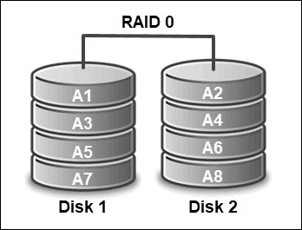

It is important to note that if an array consists of disks of different sizes, each will be limited to the smallest disk size in the setup. This means that an array composed of two disks, where one is 320 GB, and the other is 120 GB, actually has the capacity of 2 x 120 GB (or 240 GB in total).

Certain implementations allow you to utilize the remaining 200 GB for different use. Additionally, developers can implement multiple controllers (or even one per disk) to improve performance.

### **RAID 1: MIRRORING**

Unlike with RAID 0, where the focus is solely on speed and performance, the primary goal of RAID 1 is to provide redundancy. It eliminates the possibility of data loss and downtime by replacing a failed drive with its replica.

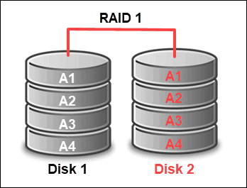

In such a setup, the array volume is as big as the smallest disk and operates as long as one drive is operational. Apart from reliability, mirroring enhances read performance as a request can be handled by any of the drives in the array. On the other hand, the write performance remains the same as with one disk and is equal to the slowest disk in the configuration.

### **RAID 5: STRIPING WITH PARITY**

RAID 5 is considered the most secure and most common RAID implementation. It combines striping and parity to provide a fast and reliable setup. Such a configuration gives the user storage usability as with RAID 1 and the performance efficiency of RAID 0.

This RAID level consists of at least three hard drives (and at most, 16). Data is divided into data strips and distributed across different disks in the array. This allows for high performance rates due to fast read data transactions which can be done simultaneously by different drives in the array.

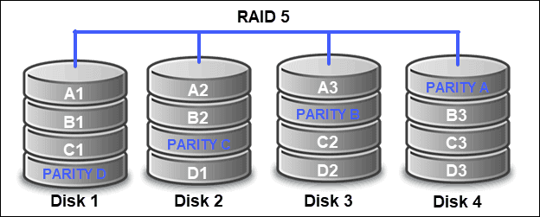

Parity bits are distributed evenly on all disks after each sequence of data has been saved. This feature ensures that you still have access to the data from parity bits in case of a failed drive. Therefore, RAID 5 provides redundancy through parity bits instead of mirroring.

Advantages of RAID 5

High performance and capacity.

Fast and reliable read speed.

Tolerates single drive failure.

Disadvantages of RAID 5

Longer rebuild time.

Uses half of the storage capacity (due to parity).

If more than one disk fails, data is lost.

More complex to implement.

# **4. WHAT IS IPC? WHAT ARE THE DIFFERENT IPC MECHANISM?**

IPS is a mechanism where OS allows various processes to communicate which each other. It involves communication of one process with each other. It involves communicate with each other. It involves communication of one process with another process. Inter-process Communication (IPC) is a mechanism for establishing a connection between processes, running on two computers or on a single multitasking computer, to allow data to flow between those processes. Inter-process communication (IPC) mechanisms are commonly used in client/server environments and are supported to various degrees by the different Microsoft Windows operating systems.

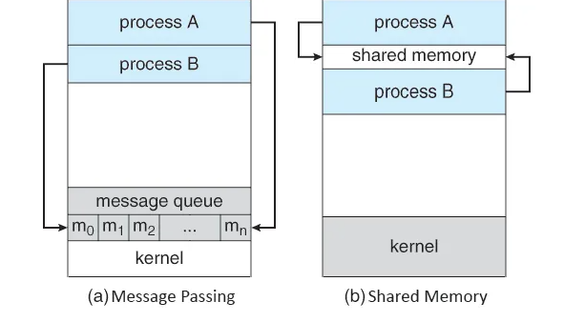

## **A. PC IN MESSAGE-PASSING SYSTEMS**

Message passing provides a mechanism to allow processes to communicate and to synchronize their actions without sharing the same address space.  
It is very useful in case where the tasks or processes reside on different computers and are connected by a network.

Messages can be of fixed or variable size. Methods for message passing operations:

## **B. IPC IN SHARED-MEMORY SYSTEMS**

A process creates the shared-memory region in its own address space. Other processes communicate by attaching the address space to their own address space.

A very famous problem called Producer Consumer Problem is used to illustrate the inner working of Shared-Memory systems. Briefly explaining

A producer process produces information that is to be consumed by the consumer.

A simple example to understand the problem is Client-server system. Considering Server as a Producer and Client as a consumer. For example, A Web server produces web content such as HTML files and images which are consumed by the client web browser.

2 types of buffers can be used, **Bounded buffer** (Fixed buffer size) and **Unbounded buffer** (No limit on buffer size).

# **5. WHAT IS VIRTUAL MEMORY?**

**Virtual**[memory](https://ecomputernotes.com/fundamental/input-output-and-memory/memory) is the feature of an [operating system](https://ecomputernotes.com/fundamental/disk-operating-system/what-is-operating-system) (OS). It is responsible for [memory](https://ecomputernotes.com/fundamental/input-output-and-memory/memory) management. In the Virtual Memory, the Physical Memory (Hard Disk) will be treated as the Logical Memory (random access memory (RAM)). Means with the help of virtual Memory, we can also temporarily increase the size of Logical Memory as from the Physical Memory. A user will see or feels that all the Programs are running into the Logical Memory of the [Computer](https://ecomputernotes.com/fundamental/introduction-to-computer/what-is-computer). With the help of virtual Memory, all the Space of Hard Disk can be used as the Logical Memory So that a user can execute any Number of programs.

Virtual memory is important for Important for improving system perform, multitasking and using large pr. since it is slower as compared to rom. This technique used in a computer technique used both hardware and software to enable.  **Virtual**[memory](https://ecomputernotes.com/fundamental/input-output-and-memory/memory) is the feature of an [operating system](https://ecomputernotes.com/fundamental/disk-operating-system/what-is-operating-system) (OS). It is responsible for [memory](https://ecomputernotes.com/fundamental/input-output-and-memory/memory) management. In the Virtual Memory the Physical Memory (Hard Disk) will be treated as the Logical Memory (random access memory (RAM)). Means with the help of virtual Memory we can also temporarily increase the size of Logical Memory as from the Physical Memory. A user will see or feels that all the Programs are running into the Logical Memory of the [Computer](https://ecomputernotes.com/fundamental/introduction-to-computer/what-is-computer). With the help of virtual Memory all the Space of Hard Disk can be used as the Logical Memory So that a user can execute any Number of programs.

# **6. DIFFERENTIATE THREAD AND PROCESS IN OS?**

A [process](https://www.notesjam.com/2017/10/process-in-operating-system.html) divided into a number of smaller tasks; each task is called a thread. A number of threads within a process executed at a time is called multithreading in OS. It divided into four categories described further. Multithreading in an operating system divided into four categories.

One Process, One Thread: In this traditional approach, the process maintains only one thread. For example, [the MS-DOS](https://en.wikipedia.org/wiki/MS-DOS) [operating system](https://www.notesjam.com/2017/09/what-is-operating-system.html) supports this approach.

One Process, Multi Threads: In this approach, a process divided into the number of threads. For example, [Java Runtime Environment](https://en.wikipedia.org/wiki/Talk%3AJava_Runtime_Environment).

Multi Processes, One Thread: Operating system supports multiple user processes but only support one thread process. For example [UNIX](https://www.notesjam.com/2017/10/architecture-of-unix-operating-system.html).

Multi Processes, Multi Threads: In this approach, a process divided into the number of threads. For example Window 2000, [Solaris](https://en.wikipedia.org/wiki/Solaris_(operating_system)), [LINUX](https://en.wikipedia.org/wiki/Linux).

Difference Between Process and Thread in OS

A process cannot share the same memory space whereas; threads can share memory and files.

It takes more time to [create a process](https://www.notesjam.com/2017/12/process-creation-in-operating-system.html) whereas; it takes less time to create a thread.

The process takes more time to complete the execution and termination whereas; thread takes less time to terminate.

Process execution is slow, but threads execute very fast.

Context switching time between two processes is much whereas; context switching time between two threads is less as compared to the process.

Implementing the communication between two processes is more difficult, but communication between the two threads is easy to implement because threads share the memory.

System calls are required to communicate with each process, but in the case of a thread, system calls not necessary.

The loosely coupled process, but tightly coupled threads.

The process requires more resources to execute whereas; the thread requires fewer resources to execute. Therefore, the thread is called a lightweight process.

A process is not suitable for parallel activity-based whereas threads are suitable for the parallel activity.

# **7. WHAT IS SCHEDULING ALGORITHM. LIST THE VARIOUS TYPES OF SCHEDULING ALGORITHM?**

**Process scheduler** assigns different processes to CPU based on particular scheduling algorithms.

## **TYPES OF PROCESS SCHEDULING ALGORITHMS**

The different types of process scheduling algorithms are as follows −

### **FCFS**

As the name goes, jobs are executed on a **first come first serve** basis. It’s a simple algorithm based on FIFO that's first in first out. It is pre-emptive and non-pre-emptive and its performance is poor based on its average waiting time.

### **SJF**

It is also known as the **shortest job first** or shortest job next. It is a pre-emptive and non-pre-emptive type algorithm that is easy to implement in batch systems and is best in minimizing the waiting time.

### **ROUND ROBIN**

It is pre-emptive scheduling algorithm in which each process is given a fix time called quantum to execute. In this time one process is allowed to execute for a quantum and then pre-empts and then other process is executed. In this way there is context switching between processes to save states of these pre-empted processes.

# **8. WHAT IS KERNEL? WRITE ITS MAIN FUNCTION.**

It is the core part of OS that provide basic service for all parts of OS. IT is the main layer between the OS and hardware and it helps with process and memory management file system, device content and networking.

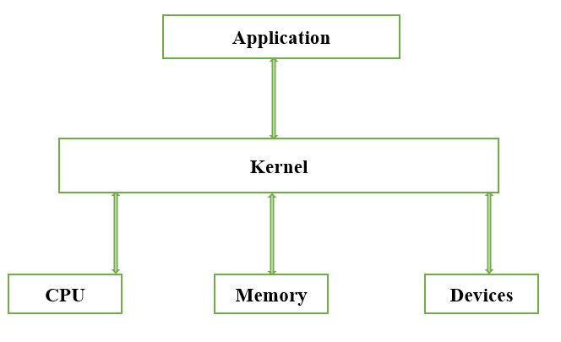

# **9. WHAT IS DEADLOCK? WHAT ARE THE NECESSARY CONDITION FOR DEADLOCK PREVENTION?**

A set of process is deadlock if process in the set is waiting for an event that only anther process in the set can cause. A deadlock is a situation in which to computer program sharing the same resource are effectively preventing each other from accessing the resource resulting in both program seizing to function. Because all the processes are waiting, none of them will ever cause any of event that could wake up any of the other member of the set and all the process continue to wait forever. There are four condition that must be satisfied in order to be a deadlock.

## **CONDITIONED TO BE DEADLOCK**

### **MUTUAL EXCLUSION CONDITION**

Its resource is either currently signed to exactly one process at time.

### **HOLD AND WAIT CONDITION**

Processes currently holding resources that were granted earlier can request new resource.

### **NO PREEMPTION CONDITION**

Resources previously granted can’t be forcefully taken away from a process. They must be explicitly release by the process holding them.

### **CIRCULAR WAIT CONDITION**

There must be a circular change of two or more processes; each of which is waiting for a resource hold by the next member of the chain

## **NECESSARY CONDITION FOR PREVENTING DEADLOCK**

There are four strategies are used for dealing with deadlock.

Just ignore the problem all together maybe if you ignored it, it will ignore you.

Detection and recovery. Let deadlock occur detect them and take action.

Dynamic avoidance by carefully resource allocation.

Prevention by instructionally negating one of the four condition necessary to cause of deadlock.

# **10. WHAT IS FCFS?**

The First Come First Serve is a non-preemptive CPU scheduling algorithm technique that technique allows you to execute on first come, first serve basis. This algorithm is easy to understand and implement. The implementation of this algorithm is based on FIFO.

This is how the FCFS CPU scheduling algorithm is done.

